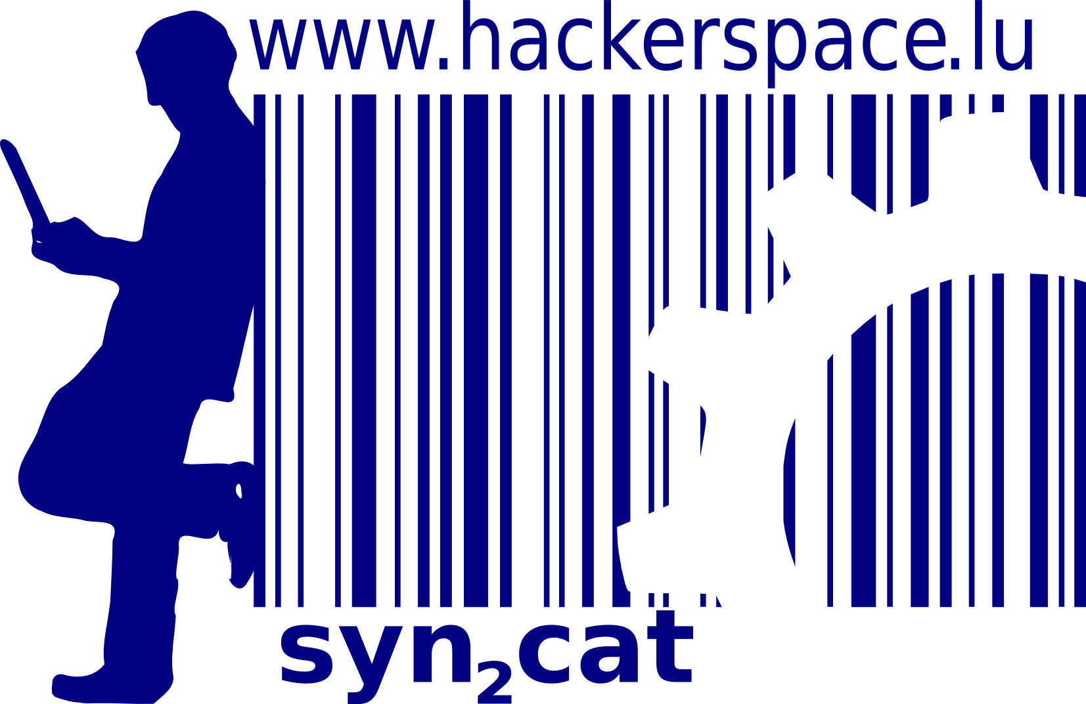


Internal regulations
Anarchy is rules without rulers

Policies
- Be excellent to each other
There should be some policies to keep order clear for everybody. Policies include...

General order (noise, general use, keys)
- Law in state counts. Normally, no noise is allowed between 22h00 and 07h00 In between these hours, please respect your neighbors, you might need them sometime! ;-)
- Keys are available on request and should be posted back after use (please ask how and where when you receive the keys). Should there be a need to use the hackerspace more than once, special arrangements can be made. Please mail us for more information
- Nobody below the age of 18 is allowed unattended access without the written consent of a tutor or parent.

Smoking
- hackerspace is a non-smoking area. However, you can smoke outside. Please try to avoid the wind blowing the smoke to the entrance door or open windows.

Housekeeping
- Everybody using the hackerspace is responsible for the equipment to stay in good shape. Using the restrooms or any other facilities entails cleaning after use.
- All material must be returned to its proper location after use.
- Projects should be stored in their proper location in between working sessions. (Exceptions can be granted on a case by case basis depending on the type of project)

Food and disposal of old food
- Everybody taking food and/or drinks to hackerspace is supposed to check regularly for their expiry dates and dispose of them, in case they're no longer consumable.
- You should check to dispose waste in an appropriate waste-bin and separate trash if possible!

More rules
- There is only one more rule: Don't make any more rules necessary!

Procedures
Procedures help fulfill important tasks using the same standards/methods every time for all users. It is important to have some for our not-so-regular members.

Startup
- Entering the snycat locations implies starting up all the systems that are there.

Shutdown
- The person "renting" hackerspace (i.e. who has the key), is also responsible for its proper shutdown. Before leaving syn2cat, please make sure that the following was checked :
- Everyone belonging to your group (including invitees) must leave the house
- Power needs to be cut
- Check that all computers are down, except those which are supposed to be running, namely:

- Control the fridge and other food/drink reserves you/your group used. Do not leave anything opened or unconsumed lying/standing around!
- Are all the lights turned off? Check the outside lights as well!
- Make sure you lock tightly both rooms and the front door before leaving the place!
- Reactivate the alarm. Red light should be on, followed by beeps.
- Do not forget to return the key and alarm badge at least 48 hours after you rented it to the address you were given.

